Use the following technical drawings to create a part drawing for each and then compile all of the parts into an assembly drawing. Do a separate part drawing for each part. Use Auto Desk Inventor.
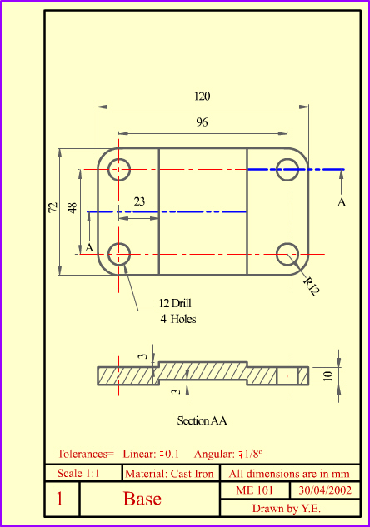
Note: All dimensions are in millimeters so choose the metric template when opening your part.ipt files.
Use the following technical drawings to create a part drawing for each and then compile all of the parts into an assembly drawing. Do a separate part drawing for each part. Use Auto Desk Inventor.
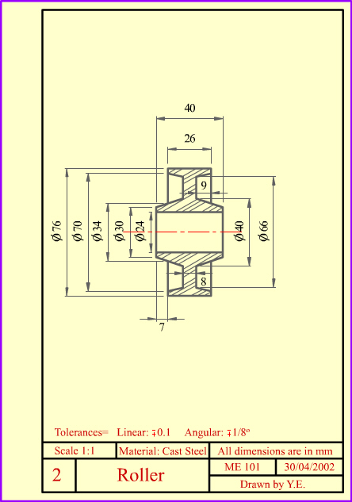
Note: All dimensions are in millimeters so choose the metric template when opening your part.ipt files.
Use the following technical drawings to create a part drawing for each and then compile all of the parts into an assembly drawing. Do a separate part drawing for each part. Use Auto Desk Inventor.
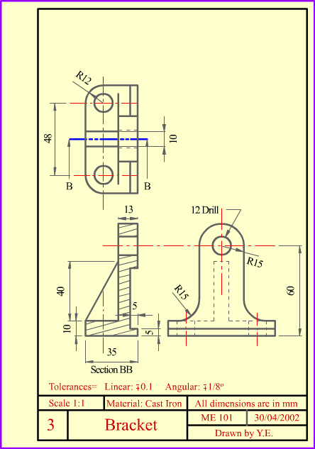
Note: All dimensions are in millimeters so choose the metric template when opening your part.ipt files.
Use the following technical drawings to create a part drawing for each and then compile all of the parts into an assembly drawing. Do a separate part drawing for each part. Use Auto Desk Inventor.
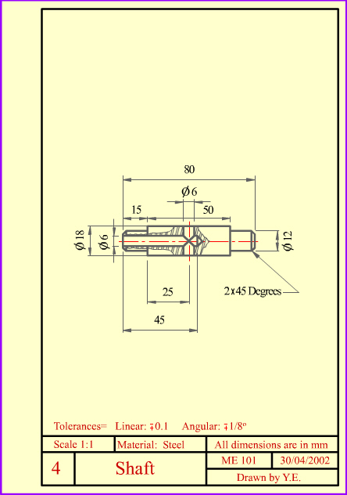
Note: All dimensions are in millimeters so choose the metric template when opening your part.ipt files.
Use the following technical drawings to create a part drawing for each and then compile all of the parts into an assembly drawing. Do a separate part drawing for each part. Use Auto Desk Inventor.
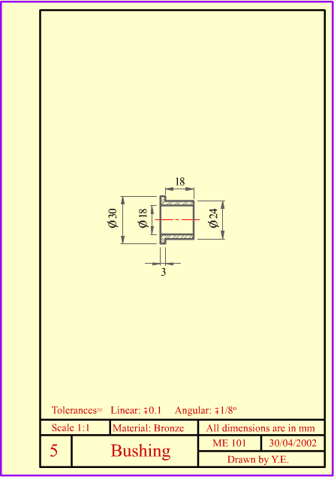
Note: All dimensions are in millimeters so choose the metric template when opening your part.ipt files.
Use the assembly drawings that follow to help yourself to create your own assembly drawing. Use Auto Desk Inventor and open a new assembly.iam file to then import all parts into this file using the “place” command at the right side corner of the top ribbon.
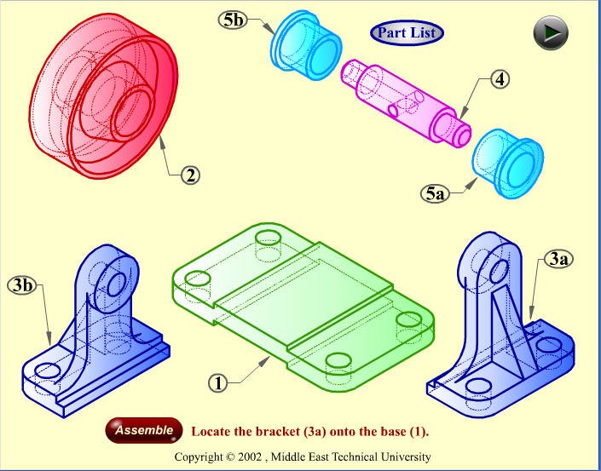
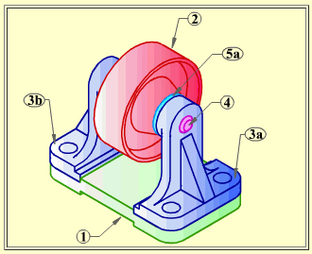
Create a multi-view drawing of each part and an assembly drawing with parts list using the drawing.idw file. Make sure you have a separate multi-view drawing for each part. After all are Technical drawings are complete create and animation which shows and exploded view drawing assembling itself then returning to its original exploded position.

Below is an overview of the concept of technical drawings based upon this exercise. This exercise was taken from the internet and the following link will direct you to the creators at Middle East Technical University:
http://www.me.metu.edu.tr/courses/me114/Lectures/assembly.htm#1

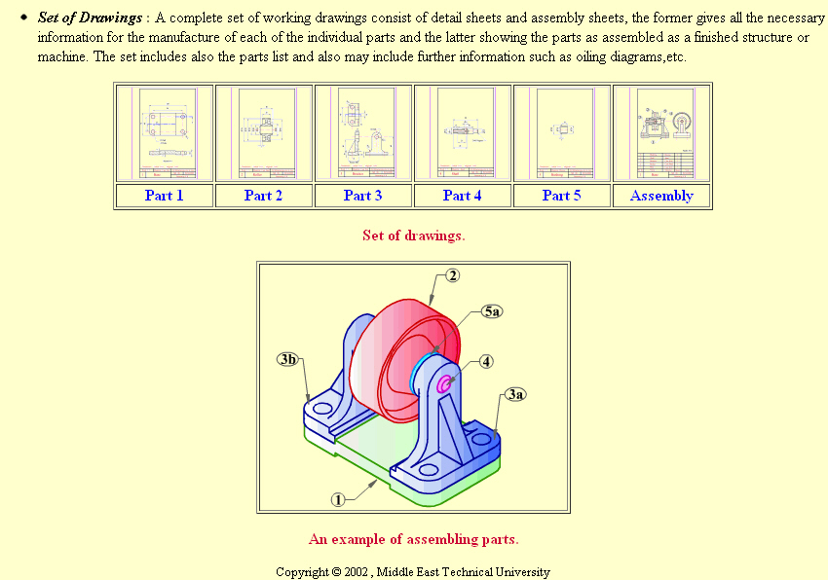

Your final activity is to go online to our class website and post on the discussion board about what you learned by doing this exercise and how your confidence level may have changed. Also include any comments on possible improvements or procedures you would suggest for future classes benefit.
http://pltwwithmrtaylor.weebly.com/poe-autodesk-activity-1-blog.html

